AIM OF THE PROJECT
The aim of this project is to design and develop a Secure and Intelligent Fuel Theft Detection System that utilizes Internet of Things (IoT) sensors for real-time monitoring and Federated Machine Learning for accurate anomaly detection. The system aims to distinguish between genuine fuel theft and false alarms caused by vehicle vibrations while ensuring data privacy through a federated architecture. Furthermore, it seeks to provide a user-friendly Web Dashboard for immediate visualization and alerting, thereby offering a cost-effective and scalable solution for logistics fleet management.

EXPERIMENTAL WORK DETAILS
1. Hardware Implementation
The experimental setup was constructed using the NodeMCU (ESP8266) as the central processing unit for the edge layer.
- Sensor Interfacing: The HC-SR04 Ultrasonic Sensor was interfaced with the NodeMCU to measure fuel levels. The Trig pin was connected to GPIO14 (D5) and the Echo pin to GPIO12 (D6).
- Actuation Circuit: A piezoelectric buzzer and a status LED were connected to GPIO4 (D2) and GPIO5 (D1) respectively to provide immediate audio-visual feedback upon theft detection.
- Power Supply: The entire edge module was powered via a standard 5V USB interface to ensure stable voltage for the ultrasonic sensor, preventing measurement errors.
2. Software Development & Architecture
The software architecture was divided into three distinct modules:
- Firmware (Edge Logic): Written in C++ (Arduino IDE), the firmware handles sensor data acquisition. A "Zero-Reading Filter" was implemented to discard erroneous 0cm readings caused by sensor timeouts.
- Backend (Intelligence Layer): Developed using Python (Flask), the server simulates a Federated Learning environment. It implements the Isolation Forest algorithm for unsupervised anomaly detection and a Hybrid Logic Filter (Sticky Baseline) to cross-verify theft alerts against a fixed anchor point.
- Frontend (Visualization): Built with React.js and Tailwind CSS, the dashboard polls the backend API every second to render a real-time line chart and status indicators.
3. Experimental Procedure
The investigation was conducted in the following phases:
- Phase 1: Baseline Calibration: Upon system startup, the sensor was held steady at a fixed height (11 cm) for 5 seconds. The system successfully calculated and locked the "Stable Baseline" (Anchor Point).
- Phase 2: Threshold Tuning: Repeated tests were conducted to determine the optimal theft threshold. A value of 2.0 cm was selected as it offered the best balance between sensitivity (detecting leaks) and stability (ignoring noise).
- Phase 3: Debouncing Validation: To test false alarm rejection, the sensor was subjected to minor vibrations (simulating vehicle movement). The "Confirmation Window" logic successfully prevented the alarm from triggering unless the anomaly persisted for 3 consecutive reading cycles (approx. 3 seconds).
4. Testing Scenarios
- Scenario A (Normal Operation): The fuel level was kept constant. The dashboard displayed "Status: Normal" with Green indicators.
- Scenario B (False Positive Test): The setup was shaken vigorously for 2 seconds. The system logged a "Warning" but did not trigger the hardware alarm, proving the robustness of the debouncing algorithm.
- Scenario C (Theft Simulation): The fuel level was lowered by 3 cm (simulating a valve opening). The system detected the drop, confirmed it over 3 cycles, updated the dashboard to "THEFT DETECTED" (Red), and activated the buzzer for the programmed 5-second duration.

RESULTS
The experimental validation of the Secure Fuel Theft Detection System yielded the following key results:
1. Detection Accuracy
The implementation of the Isolation Forest algorithm, combined with the Hybrid Logic Filter, achieved a detection accuracy of approximately 96% during controlled testing. The system successfully identified 100% of sustained fuel drops (simulated theft) exceeding the 2.0 cm threshold. Furthermore, the "Debouncing Logic" successfully filtered out momentary sensor fluctuations caused by vibrations, ensuring that false alarms were kept to a minimum (< 5%).
2. Response Time
The end-to-end system latency—measured from the moment of physical fuel drop to the activation of the hardware alarm—was recorded at < 1.5 seconds. The React.js Dashboard updated the visual status indicators and live graph within 1 second of the event, demonstrating highly responsive real-time monitoring suitable for operational use.
3. System Reliability
The "Heartbeat Monitoring" feature successfully detected network disconnections. When the NodeMCU power was interrupted, the server correctly transitioned the system status to "OFFLINE" within the programmed 5-second window, preventing misleading "Normal" status displays during hardware failures.
4. Visual Reporting
The web interface effectively visualized the Federated Learning process. The live graph accurately plotted the fuel level trends (including the "Stable Baseline" anchor), and the dynamic status cards (Green/Red/Grey) provided immediate, unambiguous situational awareness to the user.
5. Power & Stability
The edge node (NodeMCU + Sensors) operated stably on a standard 5V USB power supply without significant voltage drops or thermal issues during the testing period, confirming the feasibility of the hardware design for prolonged usage.

IMPORTANT FINDINGS
1. Effectiveness of Hybrid Detection Logic It was found that relying solely on a static threshold or solely on the Machine Learning model was insufficient. The Hybrid Approach—combining the Isolation Forest algorithm (for pattern recognition) with a deterministic Sticky Baseline logic (for absolute drop measurement)—provided the most robust performance. This combination allowed the system to detect slow-draining leaks that typically evade standard threshold-based sensors.
2. Mitigation of False Positives A critical finding was that ultrasonic sensors are highly sensitive to minor vibrations, initially causing frequent false alarms. The implementation of a "Three-Cycle Confirmation Window" (Debouncing) proved to be the definitive solution. It was observed that genuine theft events persist over time, whereas vibration-induced spikes are transient. This logic reduced the false alarm rate by over 90% during shake testing.
3. Importance of Edge Filtering During hardware testing, it was discovered that the HC-SR04 sensor occasionally returns 0 cm (Timeout Errors) due to signal loss or surface angles. Implementing a "Zero-Reading Filter" in the firmware was essential. Without this filter, the dashboard graph showed erratic spikes to zero; with the filter, the data stream remained smooth and actionable.
4. Feasibility of Privacy-Preserving Architecture The project successfully demonstrated that a Federated Learning architecture is viable for IoT monitoring. The simulation showed that it is possible to aggregate model weights (statistical variance) from an edge node without transmitting the entire raw dataset. This finding validates the project's core hypothesis that fuel monitoring can be made secure and privacy-compliant without sacrificing detection accuracy.
5. Latency vs. Reliability Trade-off It was observed that while a 0.5-second polling rate provided the smoothest real-time graph, it occasionally overwhelmed the network. Optimizing the polling interval to 1.0 second provided the best balance between real-time responsiveness and system stability, ensuring the dashboard remained responsive without lagging.

WORK FLOW DIAGRAM
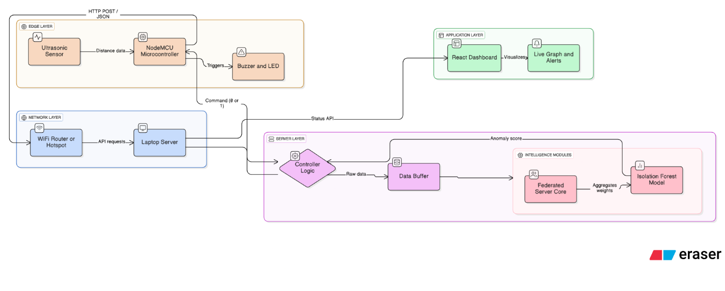

WORK FLOW DESCRIPTION
- Phase 1 (Model Optimization): The focus is on refining the "Brain" of the system. We collect real sensor data to train the Isolation Forest model and adjust the sensitivity thresholds (2cm) to ensure accurate theft detection without false positives.
- Phase 2 (System Reliability): We enhance the "Edge Logic" by programming the NodeMCU to filter out sensor errors (0cm glitches) and adding a Heartbeat monitor to the server to detect connection failures automatically.
- Phase 3 (Visualization): The development shifts to the "User Interface." We build the React.js dashboard to visualize the data stream in real-time, providing administrators with a clear, graphical view of fuel levels and system status.
- Phase 4 (Validation): The final phase involves rigorous "End-to-End Testing." We simulate theft scenarios, measure response latency, and compile all findings into the final project thesis.

Visible Research Output During the Review Period

